**NE555 astable multivibrator**

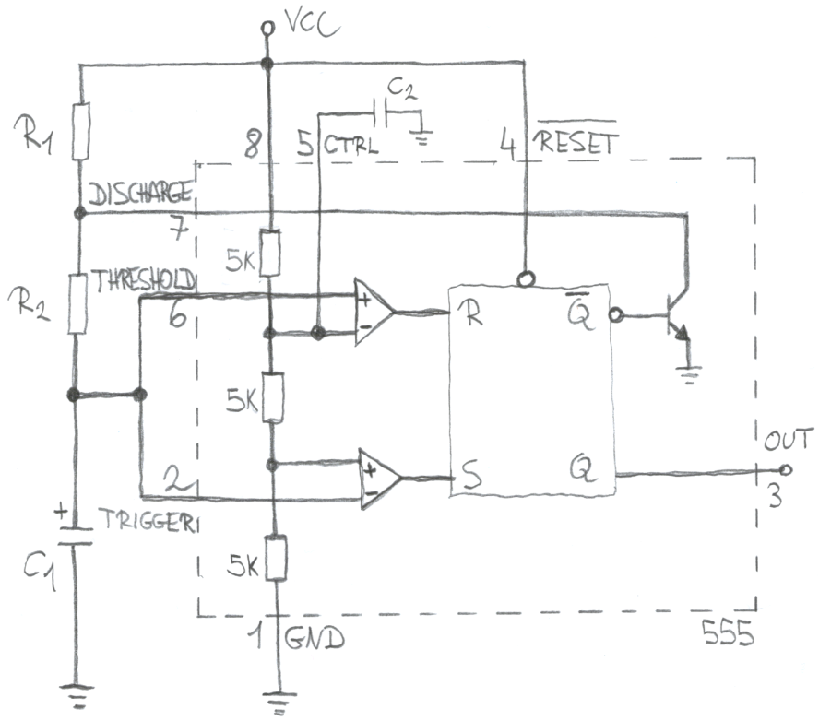

VCC is between 4.5V and 15V, the output can sink/source 200mA and C2 is usually around 10nF.

Charge phase

The capacitor charges through R1 and R2 from 1/3VCC to 2/3VCC; according to the capacitor formula:

Discharge phase

The capacitor discharges through R2 from 2/3VCC to 1/3VCC; according to the capacitor formula:

Frequency and duty-cycle

PWM circuit design

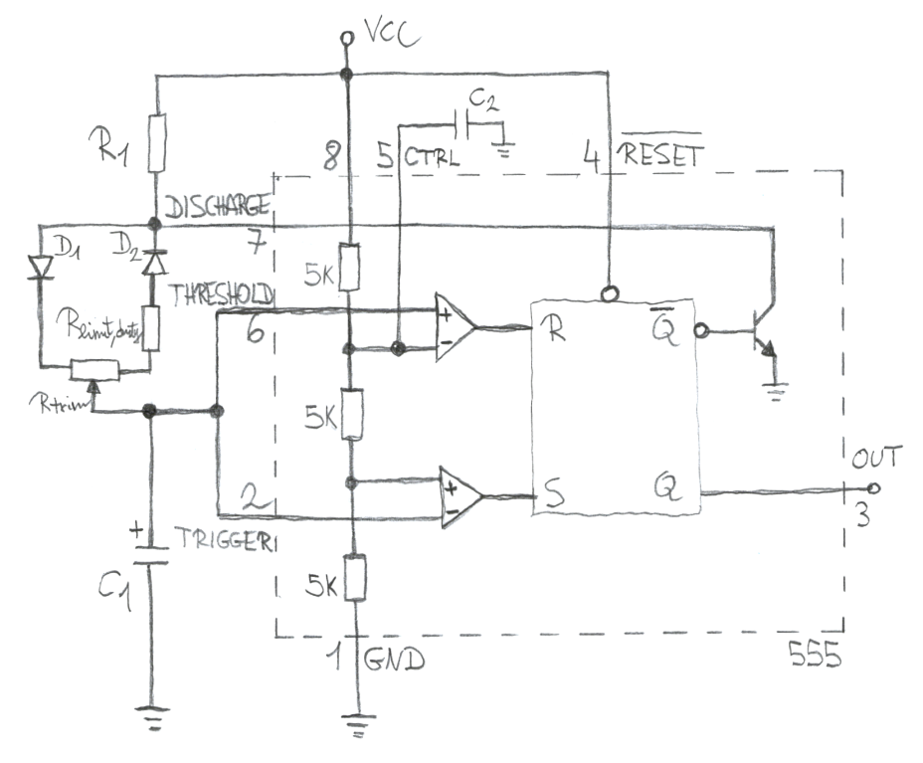

By employing a trimpot instead of R2, it’s possible to regulate the duty-cycle leaving the frequency constant. Rlimit,duty is mandatory to limit the discharge current through the internal transistor:

For example with D1=D2=1N4148, C1=100nF, C2=10nF, R1=1k, Rtrim=100k and Rlimit,duty=1k we get:

Notes:

* Remember to use a decoupling capacitor of 100nF between pin 1 and pin 8.
* Some suggest to remove R1 and connect the diodes node to OUT instead of DISCHARGE. But this circuit variant is less stable because the OUT high level is below VCC and varies with used current.
* Ceramic capacitors change their capacity with voltage and especially with DC bias. When VCC increases, C1‘s 1/3VCC DC bias also increases, the capacity decreases and the PWM frequency rises. So, if VCC cannot be held constant, then it’s suggested to use a film capacitor.